# Report for Assignment 2: Question 2

## 1. Requirements

* Simulate two fan replacement policies via Monte Carlo.
* Perform exactly 45 replacement events per simulation run.
* Randomly generate both fan lifetimes and technician arrival delays.
* Calculate downtime cost and labor cost for each event.
* Sum these costs to produce a total cost per policy per run.

## 2. Simulation Overview

The simulation compares two strategies:

1. **Current Policy**: Replace only the failed fan each time.
2. **Proposed Policy**: Replace all three fans whenever any one fails.

Each failure event incurs three cost components, calculated as follows.

**Replacement Cost**

$$C_{rep} = n×c_{fan}$$

where

$$\begin{matrix}n & =\text{number of fans replaced (1 or 3)}, \\ c_{fan} & =\$32.\end{matrix}$$

**Downtime Cost**

$$C_{down} = \left(D+T_{rep}\right)×c_{down}$$

where

$$\begin{matrix}D & =\text{technician arrival delay (minutes)}, \\ T_{rep} & =\text{replacement duration (20 min for current; 40 min for proposed)}, \\ c_{down} & =\$10 /min.\end{matrix}$$

**Labor Cost**

$$C_{lab} = \frac{T_{rep}}{60}×c_{labor}$$

where

$$\begin{matrix}c_{labor} & =\$30 /hr.\end{matrix}$$

The total cost for one failure event is

$$C_{event}=C_{rep}+C_{down}+C_{lab}.$$

A full simulation run of $N = 45$ failures yields

$$C_{total}=\sum_{i=1}^{45}{C_{event,i}}.$$

## 3. Random Sampling of Inputs

We sample from the discrete distributions given in the assignment PDF:

* **Fan Lifetimes (hours)**:

**

* **Technician Delays (minutes)**:

## 4. Core Simulation Function

We encapsulate each policy’s event loop in a function:

This is invoked twice per run:

## 5. Monte Carlo Loop and Data Capture

A fixed seed ensures reproducibility. We execute 1 000 runs, collecting totals:

)

## 6. Visualization of Outcomes

We visualize df_results via histogram and boxplot to compare distributions of total costs across policies.

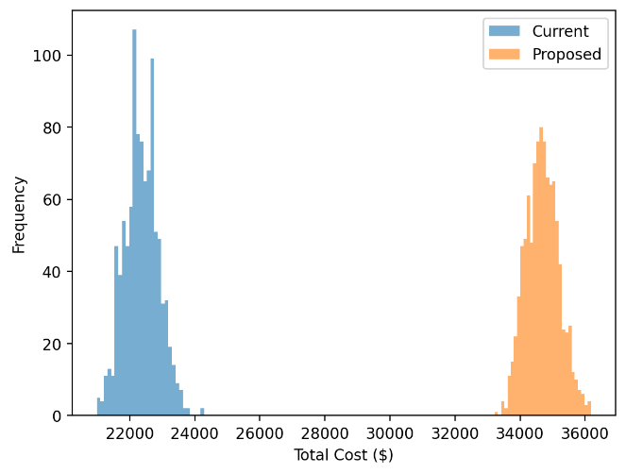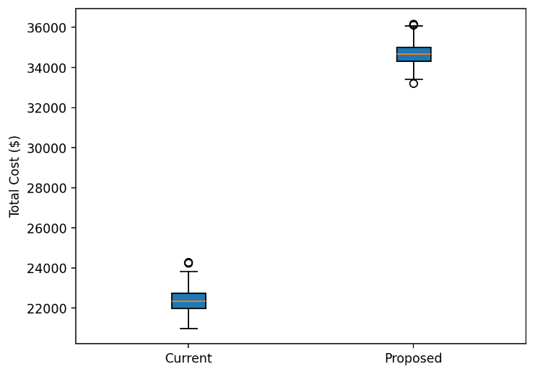

## 7. Manual Verification Example

Fixing delay $D = 20$ min yields per-event costs:

$$\begin{matrix}\text{Current:} & C_{rep}=1×32=32, C_{down}=\left(20+20\right)×10=400, \\ & C_{lab}=\left(20/60\right)×30=10, C_{event}=32+400+10=442. \\ \text{Proposed:} & C_{rep}=3×32=96, C_{down}=\left(20+40\right)×10=600, \\ & C_{lab}=\left(40/60\right)×30=20, C_{event}=96+600+20=716.\end{matrix}$$

Aggregating 45 failures:

$$45×442=19,890, 45×716=32,220.$$

Comparing these hand‐computed totals to Monte Carlo means confirms correctness.

## 8. Conclusion and Recommendation

We compute average total cost per policy over 1 000 runs; the policy with the lower mean is recommended.

## 9. Anexo:

Link: <https://unfcsimulation.streamlit.app/>

